Budget Tracker App (Python)

Project Objective
To create a simple CLI-based budget tracker using Python that helps users manage and analyze their daily expenses and income.
How It Works (Step-by-Step)
1]User Input for Transactions
- User enters either income or expense
- Each entry records:
  - Category (e.g., Food, Salary, Rent)
  - Amount
  - Date (auto-generated or user-entered)
  - Type (Income / Expense)
2] View Summary
- User can choose to view:
  - Total Income
  - Total Expenses
  - Current Balance
  - Expenses by Category
3] Filter Transactions
- Allows filtering by:
  - Specific date
  - Category
  - Type (Income/Expense)
4] Exit and Save
- All data persists in CSV for later sessions
- Can be opened and modified in Excel or reloaded by the app

Technologies Used
- Python (core logic)
- pandas (data filtering & analysis)
- csv (file handling)

Features :
- Add income with amount
- Add expenses with amount
- View total income, total expenses, and current balance
- View a complete list of past transactions with date and time
- Simple and user-friendly command-line interface

SCREENSHOTS OF PROJECT
CODE:
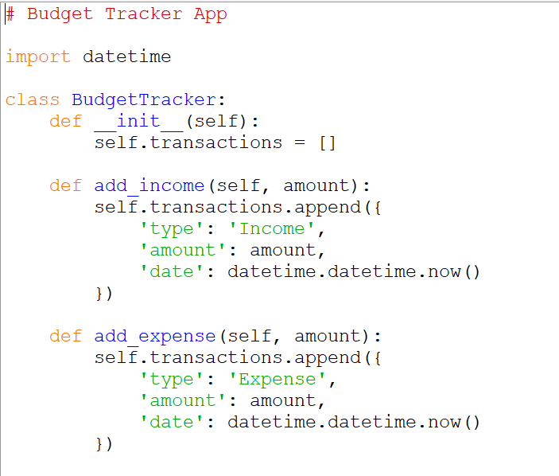
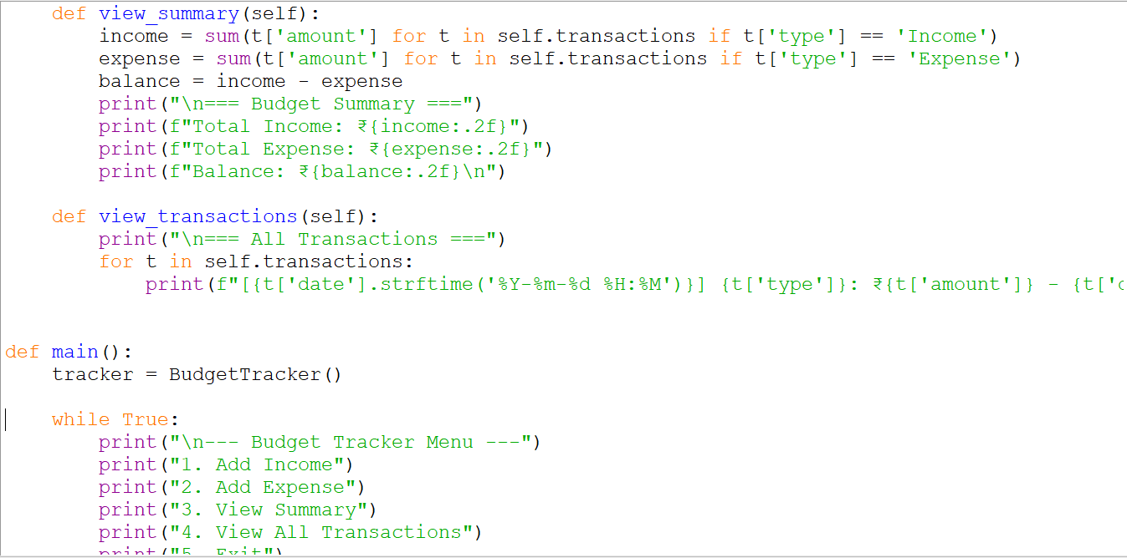
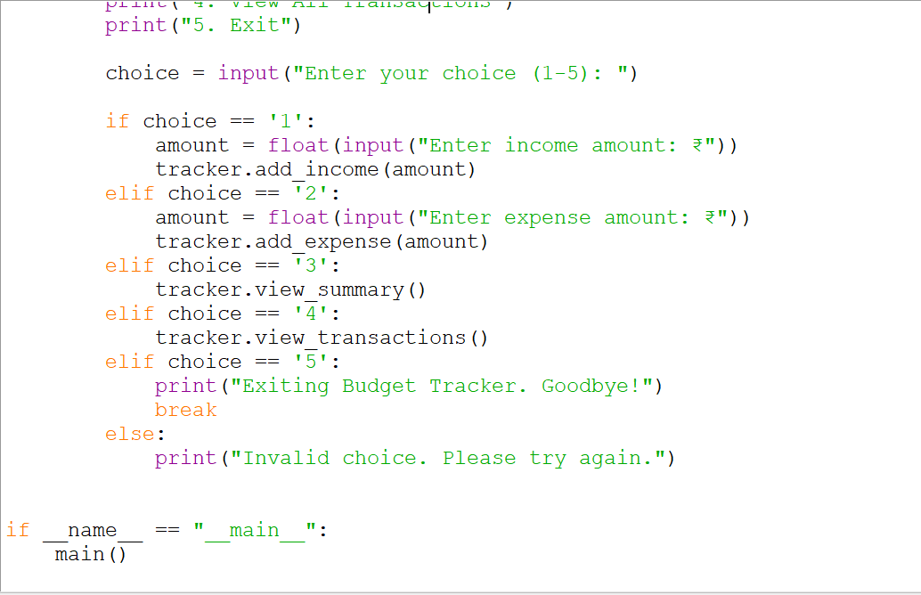
OUTPUT:
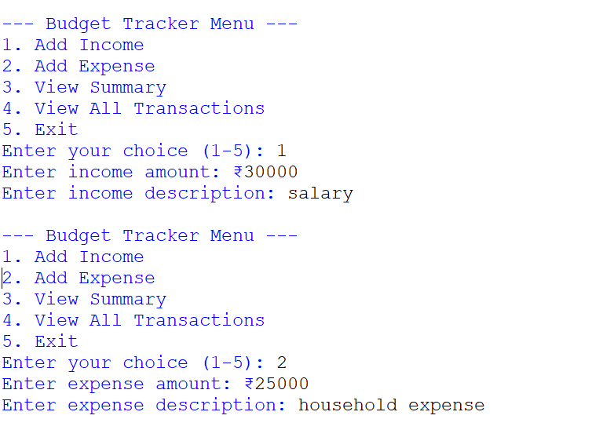
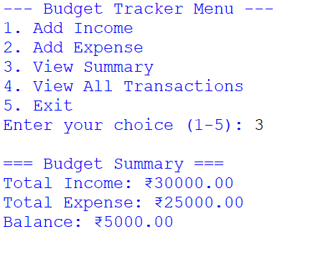
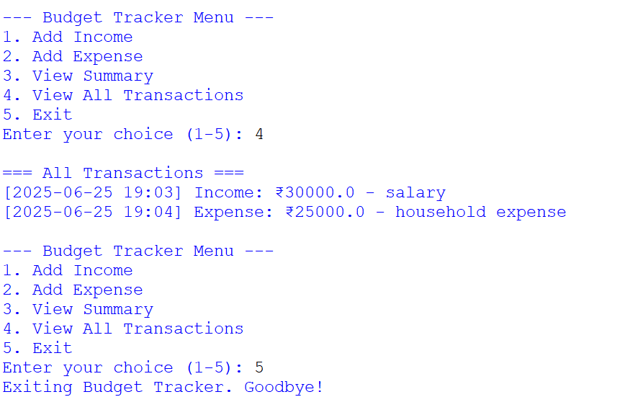
FUTURE IMPROVEMENTS
- Save transactions to a file
Store all transactions in a .csv or .json file so the data isn’t lost when the app is closed.
- Monthly summary report
Generate monthly income and expense reports automatically.
- Graphical reports
Add simple charts (e.g., bar or pie charts) using libraries like matplotlib to visualize expenses and income.
- Category-wise tracking
Allow users to assign categories like Food, Travel, Salary, etc., to better organize their spending.
- Login system for multiple users
Add basic login/logout functionality for personalized tracking.
- GUI version
Build a graphical user interface using Tkinter or PyQt for a better user experience.
- Mobile/web version
Convert the app into a mobile or web application using frameworks like Flask, Django, or React Native.
CONCLUSION
The Budget Tracker App is a simple yet effective tool to manage and monitor daily finances. By allowing users to record income and expenses, view summaries, and review past transactions, it helps build awareness of personal spending habits. Though basic, this project lays the foundation for more advanced applications such as file storage, data visualization, or mobile finance apps. With further development, it can evolve into a comprehensive personal finance management tool.

